Project Proposal

# Project

Language translator where user can enter a word and translate that word into different language options that will include German, French, Spanish and Italian.

# Functional Requirement

## The User shall…

* Be able to enter a word in different languages that will be translated
* Choose original language that will be translated
* Choose what language the word will be translated to
* Listen to the translated word with a click of a button

## The System Shall…

* Allow the user to select between different languages
* Translate the word that the user enters into the language that the user has selected
* Provide feedback if the word cannot be translated
* Voice the translated word back to the user

# Web Services

Using the Yandex API to take the user’s entered word and selected language preferences and translate the word into another language.

URL: https://translate.yandex.net/api/v1.5/tr.json/translate?key=trnsl.1.1.20190528T031652Z.482b8ef596d4fb28.f55592a1268ae66faf5206ef0a1491196acd092a&text=hello&lang=nl&options=1

# Hardware

The feature of the app where the user can listen to the pronunciation of the translated word will require the on-board speaker hardware to function. The user will be able to click a button on the app and through the speaker, be able to here the translated word being spoken back to them.

# Wireframe

A screenshot of a cell phone

Description generated with very high confidence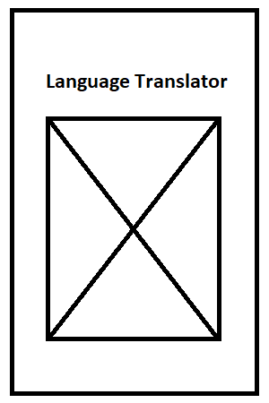

Main Screen

Welcome Screen